PURPOSE:

To ensure that any Medicare Certified Facility or Business has not engaged in either employment or a contract with another person or entity that has been placed on the OIG Exclusion list.

POLICY: (What is the OIG Exclusion List and How is it used?)

OIG has the authority to exclude individuals and entities from Federally funded health care programs pursuant to section 1128 of the Social Security Act (Act) (and from Medicare and State healthcare programs under section 1156 of the Act) and maintains a list of all currently excluded individuals and entities called the List of Excluded Individuals/Entities (LEIE). Anyone who hires an individual or entity on the LEIE may be subject to civil monetary penalties (CMP).
Exclusions are imposed for several reasons:
Mandatory exclusions: OIG is required by law to exclude from participation in all Federal health care programs individuals and entities convicted of the following types of criminal offenses: Medicare or Medicaid fraud, as well as any other offenses related to the delivery of items or services under Medicare, Medicaid, SCHIP, or other State health care programs; patient abuse or neglect; felony convictions for other health care-related fraud, theft, or other financial misconduct; and felony convictions relating to unlawful manufacture, distribution, prescription, or dispensing of controlled substances.
Permissive exclusions: OIG has discretion to exclude individuals and entities on a number of grounds, including (but not limited to) misdemeanor convictions related to health care fraud other than Medicare or a State health program, fraud in a program (other than a health care program) funded by any Federal, State or local government agency; misdemeanor convictions relating to the unlawful manufacture, distribution, prescription, or dispensing of controlled substances; suspension, revocation, or surrender of a license to provide health care for reasons bearing on professional competence, professional performance, or financial integrity; provision of unnecessary or substandard services; submission of false or fraudulent claims to a Federal health care program; engaging in unlawful kickback arrangements; defaulting on a health education loan or scholarship obligations; and controlling a sanctioned entity as an owner, officer, or managing employee.
To avoid CMP liability, health care entities need to routinely check the LEIE to ensure that new hires and current employees are not on the excluded list.
The effects of an exclusion are outlined in the Updated Special Advisory Bulletin on the Effect of Exclusion From Participation in Federal Health Programs, but the primary effect is that no payment will be made for any items or services furnished, ordered, or prescribed by an excluded individual or entity. This includes Medicare, Medicaid, and all other Federal plans and programs that provide health benefits funded directly or indirectly by the United States (other than the Federal Employees Health Benefits Plan).
OIG's exclusions process is governed by regulations that implement sections of the Act. When an individual or entity gets a Notice of Intent to Exclude (NOI), it does not necessarily mean that they will be excluded. OIG will carefully consider all material provided by the person who received the NOI as we make our decision. All exclusions implemented by OIG may be appealed to an HHS Administrative Law Judge (ALJ), and any adverse decision may be appealed to the HHS Departmental Appeals Board (DAB). Judicial review in Federal court is also available after a final decision by the DAB.

PROCEDURE:

- All applicants will be run through the database before an employment offer
- All existing employees, both salaried and hourly, shall be run through the database monthly
- All unexecuted contracts with any 3rd party business will be run through the database before contract execution
- All existing executed contracts will be run through the database every month
- Once you have queried the person or entity, simply print the screen showing the date and time of your query run
- These monthly verifications will be kept for the duration of three years from date of print
- It is acceptable to input the names and or businesses of numbers greater than one per database query (see example below)

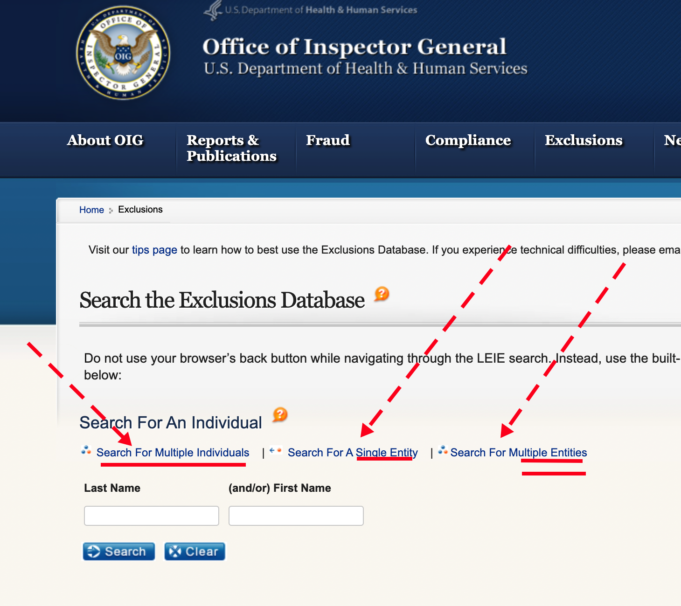

To access the database, go to the website address: https://exclusions.oig.hhs.gov/

End.

